**MATHEMATICS NOTATION**

The equations in your manuscript must follow the accepted standard math notation. There are only a few simple rules

TNR: Times New Roman or equivalent, i.e. serif font.

Variables must be italic and in Times New Roman (TNR) or equivalent.

BUT: All upper case Greek letters must be nonitalic, even if they are variables, e.g. Ψ is non italic but *ψ* is italic; Ω is nonitalic but *ω* is italic; a small change in *x* is Δ*x*

Units must be nonitalic and in TNR or equivalent, e.g. 19 V (nineteen volts), 7 A (seven amps), 3 nm (three nanometers), 10 μΩ (ten micro-ohms)

Functions must be nonitalic, in TNR without any upper case, e.g. ln*x*, sin*θ*, exp(-*i*ω*t*)

Vectors and matrices must be in bold. Normally nonitalic. They may be italic (mainly Europe) or nonitalic (mainly USA).

Subscripts to variables should be italic unless they are words or phrases, in which case they are nonitalic.

**Examples**













"exp" is non italic as it is a function

All variables, including physical constants (non-function quantities) are italic e.g. *A*, *k, T, E* etc

All units are non italic e.g. eV, K, -1 m-1

**CHEMICAL FORMULA AND EQUATIONS**

Chemical element and compound names are common nouns and should be written in lower case, unless they are at the beginning of a sentence. They are nonitalic. The chemical symbol must have the first letter in upper case as in Se.

Chemical formula should not be italic, e.g. CuSO2, copper sulfate, and not *CuSO4*, *copper sulfate.* Chemical equations must be nonitalic, e.g.

Correct Fe + CuSO4 → CuSO4 + Cu. Wrong: *Fe + CuSO4 → CuSO4 + Cu*;

Correct: Ag+(aq) + Cl(aq) → AgCl(s). Wrong: *Ag+(aq) + Cl(aq) → AgCl(s)*.

**DECIMALS AND SIGNIFICANT FIGURES**

You should quote your experimental results to the significant figures that apply to your measurements. *Significant figures are the number of digits in the result whose values are known with certainty*. It applies to the final result and not to intermediate calculations to avoid rounding errors. For example, suppose that there are 8 measurements of the resistance of a sample. You enter these into excel and calculate the average 5.779121  and the mean standard deviation is 0.069445  Then the result should be reported as 5.779 ± 0.069 . We can only be certain to the first decimal so the result as a single number without the uncertainty stated would be 5.8. (The second decimal would have no meaning due to ± 0.069 

Please read

<https://en.wikipedia.org/wiki/Significant_figures>  
<https://web.ics.purdue.edu/~lewicki/physics218/Uncertainties.pdf>  
<https://web.ics.purdue.edu/~lewicki/physics218/significant>

or other references to understand how you should report your experimental results. There are a few excellent short papers on significant figures:

1. J. F. Caballero and D. F. Harris, There Seems To Be Uncertainty about the Use of Significant Figures in Reporting Uncertainties of Results, *J. Chem. Educ.* 1998, **75** (8) 996 <https://doi.org/10.1021/ed075p996>
2. J. Bularzik, The Penny Experiment Revisited: An Illustration of Significant Figures, Accuracy, Precision, and Data Analysis, *J. Chem. Educ.* 2007, **84** (9) 1456 <https://pubs.acs.org/doi/abs/10.1021/ed084p1456>
3. J. Newbury, Errors and Significant Figures. In: *Basic Numeracy Skills and Practice*. Palgrave, London, 1981
4. G.L. Terman, Comments on significant figures in relation to experimental errors, *Agronomy Journal*, 1978, **70**, 519 <https://doi.org/10.2134/agronj1978.00021962007000030043x>

The above are for your information only and you should not be citing any of the above in representing your data. It is understood that you have used significant figures in your data reporting.

**ERROR BARS**

If you are plotting experimental points in a graph, ideally you should show the error bars. If all error bars are similar, an error bar can be placed one representative point in the graph. Otherwise they need to be shown on each point. In many cases the error bars are smaller than the symbols used in plotting the data. Then, this fact should be stated in the figure caption. The meaning of the error bars used needs to be stated in the experimental description of the work e.g. whether the error bar is one standard deviation (2** total length) or a 95% confidence interval.

**REPORTING RESULTS ON PHOTOVOLTAIC MEASUREMENTS**

The *Journal of Materials Science: Materials in Electronics* has the following requirements for the reporting of photovoltaic (PV) device performance:

Sufficient devices should be made and tested, and the numbers of these will be stated in the paper.

It is preferred that typical devices are the subject of discussion rather than ‘hero’ devices, but in all cases, it is necessary to report the average and standard deviation of the power conversion efficiency, *V*oc, FF and *J*sc;

Appropriate precision will be used when reporting PV parameters;

Experimental conditions for power conversion efficiency measurements will be stated, including:

The make, model and class of solar simulator used, as well as any protocols used to ensure accurate AM1.5G illumination;

Optical area of the device, including whether a mask was used;

Scan rate and timescale of measurement if hysteresis is observed.

**AUTHOR GUIDELINE ON THE USE OF THE SCHERRER EQUATION**

The Scherrer equation is often used to calculate nanocrystal sizes and often the results are stated to many decimal places. The quotation of such size values with several decimal places is not acceptable. **All Scherrer nanocrystal sizes should be without any decimals, to the nearest nm**. Further, since the *K*-value in Eq. (1) can vary from 0.62 to 2.08, it is important to state the *K*-value assumed. It would be helpful (although not a requirement) to calculate the uncertainty in the estimated *D* by stating that a 30% variation in the choice of the *K*-value leads to an uncertainly of ±X nm in *D*. The authors should use the general guideline below to explain that their crystallite size determination is only an *estimate*. The authors should read the reference: [**http://prism.mit.edu/XRAY/oldsite/CrystalSizeAnalysis.pdf**](http://prism.mit.edu/XRAY/oldsite/CrystalSizeAnalysis.pdf)

**WE RECOMMEND YOU USE A DESCRIPTION SIMILAR TO THE FOLLOWING. THE THREE REFERENCES SHOULD BE CITED.**

The crystallite size was estimated from the basic Scherrer equation [[1]],

 (1)

where *D* is the average crystallite size,  is the x-ray wavelength, ** is the width of the x-ray peak on the 2** axis, normally measured as full width at half maximum (FWHM) after the error due to instrumental broadening has been properly corrected (subtraction of variances), ** is the Bragg angle, and *K* is the so-called Scherrer constant. *K* depends on the crystallite shape and the size distribution, indices of the diffraction line, and the actual definition used for ** whether FWHM or integral breadth [[2]]. *K* can have values anywhere from 0.62 and 2.08. In this paper, *K* = X.X was used. Further, microstrain in the crystallite or nanocrystal also affects the width **, which needs to be considered in an accurate analysis. Spatial fluctuations in the alloy composition can also affect the width. In this work, the calculated values of *D* represent estimates. (Discussion on the accuracy of Equation (1) can be found in the literature, for example, in [3]). A discussion on x-ray diffraction peak broadening, nanoparticle dimensions and microstrain is given in Appendix A.

**[1]** P. Scherrer, "Bestimmung der Grösse und der inneren Struktur von Kolloidteilchen mittels Röntgenstrahlen", *Nachr. Ges. Wiss. Göttingen* **26** 98 (1918)

**[2]** J.I. Langford and A.J.C. Wilson, "Scherrer after Sixty Years: A Survey and Some New Results in the Determination of Crystallite Size", *J. Appl. Cryst.* **11** 102 (1978)

**[3]** V. Uvarov and I. Popov, "Metrological characterization of X-ray diffraction methods for determination of crystallite size in nano-scale materials", *Mater. Charac.* **85** 111 (2013)

**SMOOTH CURVES THROUGH EXPERIMENTAL POINTS**

If the curve does not follow a particular equation or a model i.e. the curve is a guide to the eye, then do not use spline type fitting that generates unnecessary curvatures. The examples below are unacceptable because in the left graph, the spline implies two maxima and the spline on the right graph implies two minima. Simply draw a "French curve" type smooth dashed curve as a guide to the eye. The red spline shown cannot be a guide to the eye.

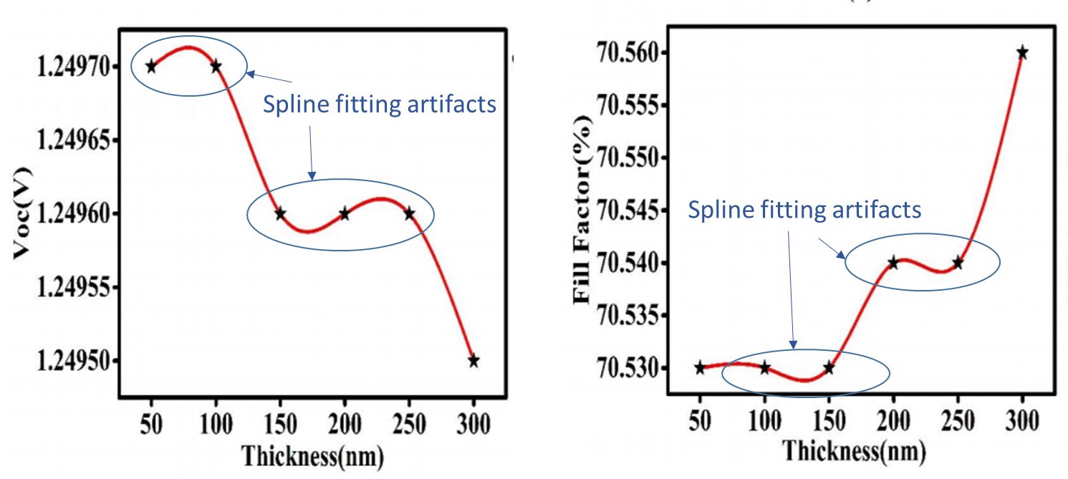

Editors  
*Journal of Materials Science: Materials in Electronics*  
A SpringerNature journal  
15 July 2021

**APPENDIX A**

**DISCUSSION FOR INFORMATION PURPOSES ONLY  
NOT TO BE USED IN ACTUAL PUBLICATION**

There are many factors that lead to the broadening of the diffraction peaks. There are several discussions in the literature, some examples of which are [[3],[4],[5]]. The residual strain in the crystallite distorts the crystal lattice and hence leads to the broadening of the diffraction peaks. In such cases, Williamson Hall analysis [[6]] should be used with Equation (1) by adding the two widths.

 (2)

where ** is the residual strain. The Williamson-Hall plot involves plotting **cos** vs. sin**. The slope gives 4** and the intercept *K/D*. A recent application of Eq. (2) to nanocrystalline SnO2 powders has shown good agreement with TEM particle size determination [[7]]. In one earlier study, single crystal (hexagonal wurtzite) ZnO nanoparticles were examined by XRD and TEM. The Williamson-Hall plots were then used to determine the nanocrystal size, approximately 19 nm, which was in reasonable agreement with the average size (20 ± 2 nm) determined from TEM. In a particular study on ZrO2 nanoparticles, the nanoparticle sizes from the Williamson-Hall plots, using *K* = 1, were 21.3 – 31.6 nm, consistently less than the average sizes determined from SEM studies, which gave 28.3 – 36.7 nm with errors in the range 14 – 25% [[8]]. Obviously a slightly different *K* could easily have brought the agreement closer (or wider apart).

Uvarov and Popov [3] have examined the use of the Scherrer equation for the determination of crystallite sizes. Their XRD and high-resolution SEM studied showed that the Sherrer prediction agreed reasonably well with SEM crystal size measurements only when the crystal size was less than 60 nm, and the crystal was three-dimensional and equiaxial. The authors state that crystallite sizes greater than 60 nm derived from the Scherrer equation should be treated with caution and electron microscopy studies would be needed to supplement the Scherrer equation calculations. In another study [[9]], authors have carefully studied the size distribution of CoPt3 quasi-spherical monodisperse nanocrystals by TEM and also by the Scherrer equation (for spherical particles, *K* = 1.2) through XRD. They considered two samples with mean diameters 4.86 ± 0.45 nm and 8.50 ± 0.59 nm. They found that the average size determined from XRD was within 5% of the average size found from TEM studies, taking into account the distribution. They showed that if one does not use the right *K* value, the nanocrystal size can be significantly different from true average size. For example, using *K* = 1, they showed that the difference is ~15%.

The agreement seems to work particularly well for small nanocrystals with relatively narrow size distribution, as clearly demonstrated by Nanda et al. for ZnS nanocrystals with a sizes 2.5 nm from HRTEM [[10]]. They used the Scherrer equation with *K* = 0.9(4/3) (or 1.2, which applies to spherical particles), and found an average size of 2.3 nm from wide angle XRD.

The above are just a few examples and there are numerous others in the literature. The choice of *K* is particularly important in the determination of the nanocrystal or crystallite size. There is an excellent free online document at http://prism.mit.edu/XRAY/oldsite/CrystalSizeAnalysis.pdf

**APPENDIX B**

Microsoft Word built-in equation editor. Under **Insert**, you will see **Equation**. Click on this and you will see **π Insert New Equation**. Click this to insert a new equation. The bar that appears allows you to insert variables, symbols, functions, matrices etc.

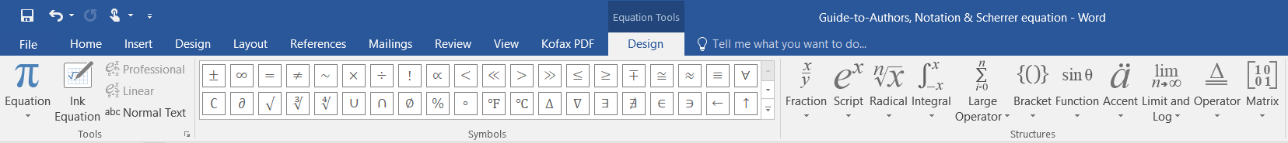

Unfortunately, it is a very poor equation editor and you have to make sure to format the variables, functions, units to follow the above rules. It does not recognize all functions so it automatically casts unrecognized functions into italics. Its font is not TNR but an equivalent (a serif font). Here are examples

$$σ^{'}=\frac{σ_{o}}{1+ω^{2}τ^{2}}$$

$$y=e^{-αt}cos⁡(ωt)$$

$$J_{recombination}=J_{ro}\left[\exp\left(\frac{eV}{2kT}\right)-1\right]$$

Unfortunately, Word does not allow you to modify the built-in math font, which is a Microsoft-based font (Cambria Math). If you follow the above simple guidelines, you would minimize typesetting errors and having your paper published with equations wrongly formatted. The journal does not publish corrections to wrongly formatted equations unless the equation is scientifically wrong.

**FURTHER EXAMPLES ON NOTATION**

Wrong:   

Correct: 

Wrong:  

Correct: 

Wrong:  

Correct: 

Wrong:  

Correct: 

Wrong: 

Wrong: 

Correct: 

Note: In the correct form, *R*sh is used but *Rsh* would be acceptable.

Wrong:  

Correct:  or  Note: Usually ln*I* is preferred to ln(*I*)

Wrong:  

Correct: 

Wrong:





Correct:



1. P. Scherrer, "Bestimmung der Grösse und der inneren Struktur von Kolloidteilchen mittels Röntgenstrahlen." Nachr. Ges. Wiss. Göttingen **26**, 98-100 (1918)
2. J.I. Langford and A.J.C. Wilson, “Scherrer after Sixty Years: A Survey and Some New Results in the Determination of Crystallite Size,” J. Appl. Cryst. **11** (1978) pp 102-113
3. B.D. Cullity, Elements of X-Ray Diffraction, Second Edition, Addison Wesley, Reading, MA, USA, pp284+
4. Allen W. Burton*, Kenneth Ong, Thomas Rea, Ignatius Y. Chan, Microporous and Mesoporous Materials 117 (2009) 75–90,
5. V. Uvarov and I. Popov, Mater. Charac. **85**, 111 (2013)
6. G.K. Williamson, W.H. Hall, Acta. Metall. **1** (1953) 22–31.
7. P. Muhammed Shafi and A. Chandra Bose, AIP Advances **5**, 057137 (2015) (https://aip.scitation.org/doi/10.1063/1.4921452)
8. K. A. Aly, N.M. Khalil, Y. Algamal , Q. M.A. Saleem, Estimation of lattice strain for zirconia nano-particles based on Williamson- Hall analysis, Matewr. Chem. Phys., **193** (2017) 182-1888
9. H. Borchert, E. V. Shevchenko, A. Robert, I. Mekis, A. Kornowski, G. Grübel, H. Weller, Determination of Nanocrystal Sizes:  A Comparison of TEM, SAXS, and XRD Studies of Highly Monodisperse CoPt3 Particles, Langmuir, **21**, 5, 1931-1936 (2005)
10. J. Nanda, Sameer Sapra, D. D. Sarma, Nirmala Chandrasekharan, Gary Hodes, Size-Selected Zinc Sulfide Nanocrystallites:  Synthesis, Structure, and Optical Studies, Chem. Mater. 2000, 12, 4, 1018-1024